A Low-Overhead Method for Software Process Appraisal

F.G.Wilkie¹, F.Mc Caffery², D.McFall¹, Neil Lester¹ and Emmanuel Wilkinson

¹ Centre for Software Process Technologies
Faculty of Engineering
University of Ulster
Newtownabbey
Co-Antrim BT37 0QB
Northern Ireland
fg.wilkie@ulster.ac.uk , d.mcfall@ulster.ac.uk , ng.lester@ulster.ac.uk

² Irish Software Engineering Research Centre (ISERC)
University of Limerick
Limerick
Ireland.
Fergal.mccaffery@dkit.ie

Abstract

This paper describes a low-overhead method of software process appraisal that has been developed and used by the Centre for Software Process Technologies (CSPT) to appraise small-to-medium-sized software development organisations in Northern Ireland (NI) that have little or no experience of software process improvement programmes.

During the appraisal, information is collected and reviewed to produce a findings report. The findings report consists of a list of strengths, issues and suggested actions for each of the process areas evaluated. The suggested actions detail how the assessed company may improve their processes in line with their business goals. Because the NI software industry is mainly composed of small-to-medium sized software development companies, it is sometimes difficult, both in terms of financial expense and time, for such companies to engage in regular appraisals with the CSPT appraisal team. Therefore, since the main purpose of the CSPT is to instil a software process improvement culture into the NI software industry a pragmatic and relatively non-evasive solution has been developed.

This solution has two parts. The first part enables an initial software process appraisal to be performed on-site by the CSPT appraisal team. The second part is an on-line appraisal tool used by the company itself during follow-on periodic self-appraisals.

KEYWORDS: CMMI, Light-weight appraisal, SME, Software engineering practices, On-line self-appraisal.

1. INTRODUCTION

The Centre for Software Process Technologies (CSPT 2003, Wilkie et al. 2004) is a research and knowledge transfer group funded jointly by the University of Ulster and Invest Northern Ireland, a Northern Ireland governmental organisation charged with the economic development of this geographical region. The CSPT is tasked with motivating and supporting a culture of software process improvement within the Northern Ireland (NI) software industry (Mc Caffery et al. 2004).

The Software Engineering Institute has been transitioning from the Capability Maturity Model (SW-CMM) (SEI 1994) to the Capability Maturity Model Integrated (CMMI®) (Chrissis et al. 2003) for the past few years. The CSPT favours the continuous representation as opposed to the staged model of the CMMI®, since it is a more attractive proposition for small-to-medium sized (SMEs) companies which characterise the NI software industry – particularly where most of these companies have no compelling reason to achieve any particular maturity level rating, but would rather see the benefits from a software process improvement programme in perhaps a more gradual, progressive manner. Such an approach clearly fits better with the continuous representation than with a staged representation because the scope of any appraisal, in terms of the process areas investigated, can be narrow or broad, being more easily tuned to the business needs of the assessed company. We refer to this as the ‘breadth’ of the investigation.

Three categories of appraisal method are available for assessing processes within organisations against the CMMI® model. These methods are known as class-A, class-B and class-C and are developed to comply with the Appraisal Requirements for CMMI® (ARC) (SEI 2001). Class-A methods involve a significant effort from the appraised organisation both in terms of preparation for such an appraisal as well as considerable external effort from an appraisal team. This large effort is largely due to the fact that there is a requirement to investigate thoroughly and corroborate any evidence gathered during appraisal. We refer to this concept as the ‘depth’ of the appraisal. As the NI software industry is mainly composed of SME companies, class-A methods would not currently be appropriate because the depth of the appraisal would prove too expensive in terms of both effort involved and cost. Therefore the CSPT approach has been to build up awareness and understanding in the aims and objectives of software process improvement in a gradual manner. In order to be adopted by the local software industry, it was necessary to initially keep the costs and preparation time associated with such methods to a minimum. This was possible through an approach of narrowing the breadth and reducing the appraisal depth. For this reason the CSPT has developed its own appraisal method which follows the intent of the ARC 1.1 for a class-C method, with some minor additions. Our method is called Express Process Appraisal (EPA).

The EPA method has been used to appraise six software development companies in NI. The results of all six appraisals are documented (Wilkie et al. 2005). Our results indicate that for most of the process areas, most appraised companies performed at either capability level 0 or 1. The intention of this paper is to describe the method, our experiences using it and the benefits this geographical region has so far realised from its deployment.

Section 2 describes the EPA method in detail, while section 3 discusses our experiences with the method involving 6 software companies. Section 4 describes how the method has been extended in a second phase by offering companies the opportunity to perform self-appraisal of their processes as a follow-up to the EPA appraisal. Section 5 relates our work to that of others, and section 6 offers our concluding remarks.

2. EXPRESS PROCESS APPRAISAL

The EPA method was developed during 2003. A team of five CSPT staff were involved in developing sets of questions from the CMMI® to enable us to ensure adequate coverage of the model during questioning sessions. Two members of this team had previously attended the official ‘Introduction to CMMI®’ course and subsequently the ‘Intermediate Concepts of CMMI®’ course, both at the Software Engineering Institute. Additionally, one of this team had also participated as a team member on both CMM and CMMI® appraisal teams led by fully (SEI) qualified Lead Assessors.

2.1 Selecting Process Areas

We decided that the EPA method should be used to assess six of the process areas at maturity level 2: Requirements Management, Configuration Management, Project Planning, Project Monitoring & Control, Measurement & Analysis and Process & Product Quality Assurance. These are 6 of the 7 process areas associated with maturity level 2 and therefore the justification for starting a process improvement exercise with them is already well established – they constitute the engineering management basis of an organisation and the first level in the model.

The reason for not including the seventh CMMI® process area, namely Supplier Agreement Management (SAM) was two-fold. Firstly, we wished to confine the interview session to one working day (7 hours). Six process areas are as many as can reasonably be covered in this timeframe. Secondly, by omitting one process area, we hoped to avoid situations where a company might attempt to claim some form of maturity level 2 compliance in the event that we discovered no issues or weaknesses in the process areas appraised. Following the intent of a class-C method, EPA does not provide any form of rating. This is explained to all appraised organisations from the outset, but there is, nevertheless, a tendency for organisations to try to judge their performance against maturity levels, and by omitting one process area we effectively diffuse this potential difficulty.

The EPA method was designed to assess software processes within software development companies with little or no previous experience of software process improvement programmes, and so it was decided not to assess the generic practices for each of the process areas. Therefore the EPA method is currently limited to appraising the specific practices for each of the process areas mentioned previously.

2.2 The EPA Appraisal Plan

The EPA method is divided into eight easy steps which are outlined in figure 1. The appraisal team consists of two CSPT staff members who conduct the appraisal between them. Most of the stages are collaborative (stages 3,4,5,6 and 7). Stages 1, 2 and 8 are mainly conducted by the appraisal team lead only.

Stage 1 (Develop Appraisal Schedule) is the preliminary meeting to establish logistics and determine the schedule. During stage 2 (Conduct Overview Briefing) the lead appraiser provides an overview of the method for all those from the appraised organisation who will be involved in subsequent stages. This session is used to allay fears and concerns that individuals may have and to establish codes of conduct and confidentiality.

The site briefing in stage 3 is used by the appraised organisation to explain elements of the company structures to the appraisal team. During this stage, the appraisal team learn a little about the company history, the company’s business objectives and about the types, sizes and business value of ongoing projects, along with the lifecycle stage that each project has reached.

Stage 4 (Analyse Key Documents) provides a brief look at some samples of project and organisational documentation. Five samples of documents are requested: a typical project plan, a typical project progress report, a typical approved requirements statement, company quality assurance guidelines/manual and finally any documentation relating to the company policy on configuration management. The ARC class-C does not require EPA to consider documentation. The method is required to consider “at least one source of data”. The primary source of data for EPA is through a series of interviews conducted during stage 5. The brief consideration of some sample documents during stage 4 is additional and used mainly to craft further questions for stage 5.

The core of the method is stage 5 (Examine and Document Objective Evidence). In this stage key staff members from the appraised organisation are interviewed. There are 6 interviews. Each interview is scheduled to last approximately 1 hour. Each interview focuses on one of the 6 process areas.

Off Site On-Site
1. Develop Appraisal Schedule
1 hour

3. Conduct Site Briefing
2 hours
4. Analyse Key Documents
3 person hours
5. Examine and Document
Objective Evidence

7 hours elapsed time

6. Generate Appraisal Results
3 hours
7. Create Final Report
3 hours

8. Deliver Final Report
1 hour
3 elapsed days (typically)
5 elapsed days (typically)
Anticipated Sequence

Alternative Sequence

Critical Schedule

2. Conduct Overview Briefing
2 hours
2 elapsed days (typically)

Figure 1 – The eight stages of the Express Process Appraisal

The schedule of interviews has been carefully designed. The first interview covers Requirements Management, the second covers Configuration Management; the third is Project Planning, followed by Project Monitoring & Control. The last two interview sessions cover Measurement & Analysis and then Product & Process Quality Assurance respectively. Each interview involves the appraisal team plus between 1-5 staff from the appraised organisation. Staff are not required to prepare for the interviews. The staff may come from any project teams within the organisation - the only obvious requirement is that they be able to answer questions in their scheduled session knowledgably.

Stages 6 and 7 (Generate Appraisal Results and Create Final Report) are very much a collaborative exercise between the two appraisal team members. The final report consists of a list of strengths, issues and suggested actions for each of the process areas evaluated. Global observations covering all process areas are also covered. This report is presented to the group of people in the appraised organisation who participated in the interviews.

Overall, EPA requires about 42 person-hours of the appraised organisation’s time. Ideally the whole appraisal process is completed over two elapsed weeks.

From our experience, a summary of the effort required to complete each stage of the EPA is presented in table 1.

Stage | CSPT  (person-hours) | Appraised Organisation  (person-hours)
1 | 2 | 1
2 | 4 | 14 (estimate)
3 | 4 | 4
4 | 6 | 1
5 | 14 | 18 (estimate)
6 | 6 | 0
7 | 6 | 0
8 | 2 | 4
Totals | 44 | 42

Table 1 – Effort involved in conducting Express Process

3. EXPERIENCES USING EPA

In this section we examine the method from four points of view: (i) the benefits to a company; (ii) the benefits to our research centre; (iii) observations related to the performance of the EPA method and (iv) limitations of the EPA method.

The EPA method has been used to appraise 6 separate companies. Four of these companies employed between 10-45 engineers and therefore represent the ‘small’ category of SMEs. The other two appraised companies employed between 60-120 software engineering staff and therefore represent the ‘medium’ category of SMEs. All six organisations have been operating for at least 4 years. Five of the appraised organisations are product-based while the sixth is a software services company. The fact that all of these organisations have been in business, developing software, for several years suggests that from an engineering and management standpoint, these companies are all doing “enough” of the right activities to survive, that is, the essentials are in place.

The six process areas, mentioned earlier, were confirmed as applicable to all companies in our sample, prior to the appraisals taking place.

3.1 The Benefits to an Appraised Organisation

The NI software industry is characterised as small to medium sized enterprises driven by entrepreneurs and lacking a quality culture (McFall et al.2003). In such an environment it is very difficult for software organisations to appreciate the global importance of both software product and process quality. Part of the problem is one of education where software development managers fail to understand how to improve their business and further fail to appreciate their company’s technical performance with regard to international standards.

To combat this requires an appropriate approach that will facilitate education and begin to engage software managers in a quality agenda. EPA helps in several ways. Firstly, the marketing of EPA has raised awareness of software process improvement. Then, the application of the method has raised the level of education within the appraised organisations. Finally, the appraisal results have provided a road map for software process improvement within each appraised organisation.

By requiring only 6 person-days of internal staff time and a similar amount of external appraiser time, EPA has proved attractive to SME organisations from the standpoint of costs. This has been important for the CSPT since our objective is to stimulate process improvement programmes. In this respect we have witnessed the method not only contributing to the diagnosing stage in the IDEALSM model (SEI 2005, McFeeley 1996) but also to the initiating stage in helping secure sponsorship to begin the first improvement cycle.

3.2 The Benefits to our Research Centre

Three main benefits have been observed so far. Firstly, much of our research is of an empirical nature. It is therefore important that we gain access to valid data from commercial sources. EPA, by appealing to industry, has provided a good vehicle for gaining access to commercial domains from which such data is obtained. Secondly, CSPT is a university-based centre and is not driven by a profit motive. Many of the CSPT staff are academics who must balance a wide variety of commitments. EPA makes fewer demands upon such schedules and is therefore easy to deploy. Finally, EPA helps us fulfil one of the University’s main objectives in respect of its knowledge transfer agenda.

3.3 Observations on the use of the EPA Method

One hour is sufficient time to cover each of the requirements management and configuration management process areas. However, the Project Planning process area typically required 1½ hours to complete – as did Project Monitoring and Control. The Measurement & Analysis and Product & Process Quality Assurance process area interviews tended to require only 45 minutes each.

The power of the method is in having two appraisal team members. During each of the interview sessions, one of the team led the questioning while the other made notes. The person leading the session had a PC based tool which enabled them to make snap judgements about the answers being given by judging on a discrete set of values – Red (not practiced), Amber (partially practiced), Yellow (largely practiced) and Green (fully practiced). In this way, the opinions of the questioner could also be recorded for subsequent review. A screen-shot from the tool is presented in figure 2.

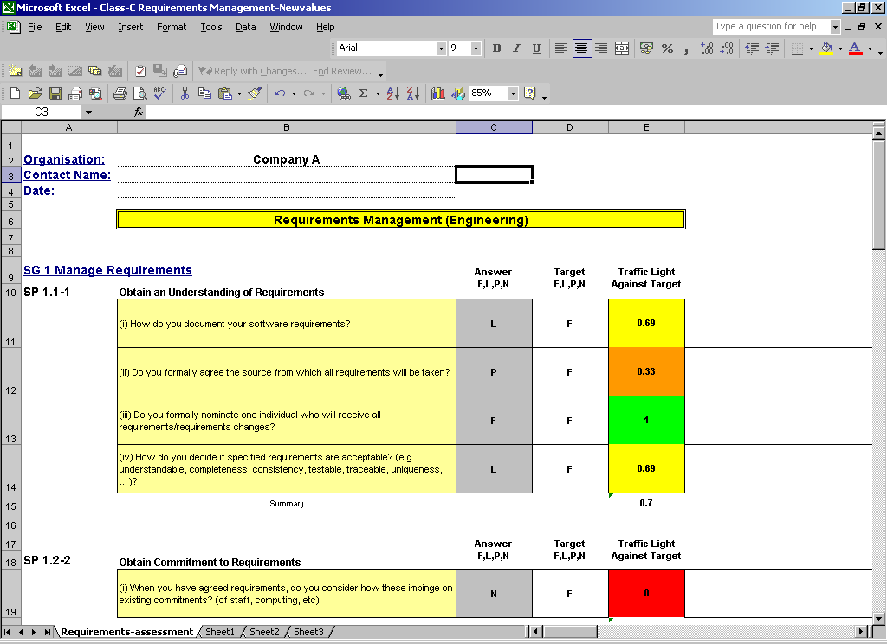

Figure 2 – Screen-Shot from the EPA Tool

During stages 6 and 7, both appraisers discussed the findings and the spreadsheets used to record snap judgements were revised. When both appraisers were happy, the tool produced histograms which proved very useful in judging performance against CMMI® process area goals. The tool also produced histograms for practices within goals, but these proved less useful for a variety of reasons. In particular, some CMMI® practices resulted in more questions than others. The histograms were based on the answers to the questions – so statistically, some practices were subject to smoothing effects from multiple answers to a greater or lesser extent than others – whereas all goals were subject to this smoothing since, at the goal level, there were always many answers to be consolidated.

In stage 7, the final report is developed by the two appraisers reviewing the notes, specific practice scores and the histograms produced by the EPA tool for each of the 6 assessed process areas. The appraisers produce the final report by sequentially reviewing the data obtained for each of the process areas and documenting an agreed set of strengths, issues and suggested actions. The final report takes the format of a Microsoft PowerPoint presentation that lists a set of strengths, issues and suggested actions for each of the process areas, plus a list of global observations that affected all process areas.

3.4 Limitations of the EPA Method

The EPA method is designed as a light-weight appraisal method to be used within organisations that have very little experience of software process improvement. The method relies heavily on information obtained from interviewing company personnel and performs limited cross-referencing checks (due to the limited time available for data collection and analysis). In other words, it lacks ‘depth’ as defined earlier. As a result, this approach depends on the willingness of the company to engage in software process improvement. It is important that the company encourages it’s employees to answer interview questions in a truthful and helpful manner so that the resultant findings report will provide an accurate reflection of the company’s strengths and weaknesses within each of the appraised process areas. The findings report contains a list of recommendations which each company must prioritise into an action plan based upon their goals and aspirations.

In addition, within the parameters of the method’s schedule, there is no provision for a company to choose any six specific process areas from the CMMI® suite of twenty-five process areas. In order to achieve this, extra resources would be required to educate the organisation being appraised on the CMMI® process areas and in examining these with relation to business objectives. This was judged to be an avoidable cost.

4. EXTENDING EPA - CONTINUOUS SOFTWARE PROCESS APPRAISAL
The main purpose of the CSPT is to instil a software process improvement culture into the NI software industry. Therefore, in an attempt to attract small-to-medium-sized organisations to engage in continuous process appraisal it was necessary to further reduce the overhead as well as increasing the flexibility and accessibility of the appraisal. The CSPT has therefore developed the Extended-EPA method. The Extended-EPA method consists of two parts. The first part is the EPA method as outlined in previous sections. The second part is an on-line process appraisal tool to enable software development organisations to perform self-appraisal of selected process areas that have previously been assessed by the CSPT appraisal team using the EPA method. The main reason for this is to ensure an understanding of the questions.

This tool enables software development companies to self-assess their processes periodically, to determine if the capabilities of their software processes have improved as a result of implementing the actions suggested by the CSPT appraisal team during the initial EPA.

The tool is only available to organisations that have previously had their processes assessed using the CSPT’s EPA method. As the tool is web-based it is easily distributed to companies. Eligible companies may access the tool upon demand. This enables company personnel to perform a process self-appraisal in an informal, flexible manner, with minimal preparation being required prior to performing the appraisal. As illustrated below in table 2 the self-appraisal tool requires no external CSPT time and only an estimated time of 6 hours from a company employee who attended the initial EPA to perform the appraisal for all 6 process areas that were originally appraised in the EPA.

Stage | CSPT  (person-hours) | Appraised Organisation  (person-hours)
1 | 0 | 0
2 | 0 | 0
3 | 0 | 0
4 | 0 | 0
5 | 0 | 6* (1 hr for each process area)
6 | 0 | 0 automated
7 | 0 | 0
8 | 0 | 0
Totals | 0 | 6

- Assuming that the respondent is able to find suitable choices from the multi-choice answers provided as standard.

Table 2 – Effort involved in conducting Self-Appraisal version of the Express Process

Whilst a company may access the full range of questions that were used in the EPA method by the CSPT appraisal team, the company may only access those process areas in which they were previously appraised. The questions within each process area have multiple choice answers. These possible answers are expressed in terms that do not require an understanding of the CMMI model (see figure 3). However, a facility is also provided that permits users to enter a free text answer if they feel that none of the options fully equates to their required response. This response is then automatically emailed to a member of the CSPT appraisal team who will make a judgement and provide feedback. The tool also enables an appraisal to be performed on one process area, in isolation from other process areas. A process appraisal does not have to be completed in a single session; it may be partially saved and then continued in later sessions.

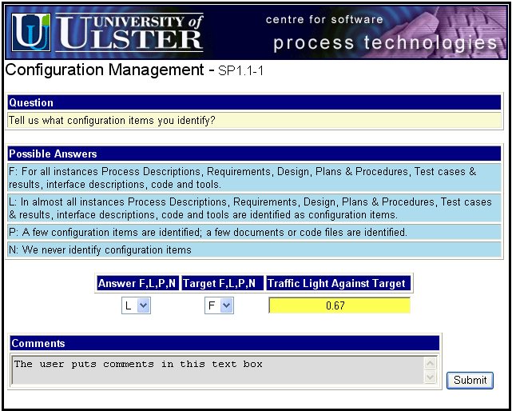

Figure 3. The EPA Self-Appraisal tool

Records of each appraisal are stored and used to monitor software process improvement over time. This information is also accessible to the CSPT so that empirical software process improvement information may be compiled.

4.1 The Management Facilities of the Extended-EPA Self-Appraisal Tool

The self-appraisal tool consists of a five main parts:
- User Account Management
- Process Area Management
- Question Management
- Process Appraisal
- Help

The first 3 sections User Account Management, Process Area Management and Question Management are only visible to the CSPT team. The only sections that may be accessed by company personnel are Process Appraisal and Help.

The self-appraisal tool adheres to the CMMI structure.

The User Account Management section provides management features for user registration, checking that the user is authorised, resetting user passwords, adding user accounts, deleting existing user accounts, amending user accounts and exiting the appraisal.

The Process Area Management section facilitates the addition of new process areas and goals/practices within process areas, the amendment of existing process areas or goals/practices, or the deletion of existing process areas or goals/practices.

The Question Management section enables the addition of new process area questions to practices, the amendment of existing questions, or the deletion of existing questions.

The Process Appraisal section enables the user to access each process area that their company has previously been assessed in by the EPA. This section enables a user to perform the self-appraisal of one or more process areas. After the appraisal is completed for a process area the results may be viewed in either textual or graphical format. Figure 4, illustrates sample results for the self-appraisal of the Configuration Management practices. The results of the appraisal are time-stamped and a copy is automatically stored for future reference by the CSPT.

A user may partly complete answering questions on a process area or several process areas in one session, then save their work and resume during a subsequent session, allowing for the option of leaving the system in order to perhaps ascertain the answer to a particular question. The tool will allow several users to make separate evaluations of process areas and this enables consistency checking to be performed and therefore increases confidence levels.

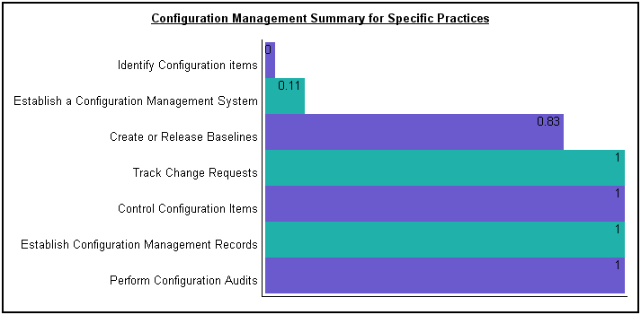

Figure 4. Sample results for the self-appraisal of the Configuration Management process area.

5. RELATED WORK

Process appraisal methods generally draw upon one of two process models: (i) ISO/IEC 15504 (ISO/IEC 15504-3 2004) and (ii) CMMI® (Chrissis et al. 2003). Using each of these models there have been many attempts to develop light-weight process appraisal methods. For example, RAPID (Rout et al. 2001), SPINI (Makinen 2000), FAME (Fraunhofer Institute 2005), TOPS (Cignoni 1999), and MARES (Anacleto et. al 2004a) are all based on the ISO/15504/5 (ISO/IEC 15504 2003) reference model.

Anacleto et al. (Anacleto et. al 2004b) have considered process appraisal methods for small software companies. In their paper they provide a framework for comparing appraisal methods and have compared most of the methods mentioned above. They suggest that appraisal methods “either provide a method for a fixed set of processes or in correspondence with the specific characteristics and goals of an organisation select a set of processes to be investigated.” Our EPA method has been used in the former style where we pre-selected a set of 6 process areas to appraise. However, EPA could equally well be employed with a set of process areas determined in consultation with the organisation to be appraised. Those process areas being drawn from the full suite of 25 within the continuous representation of CMMI® and within the constraints of EPA where the evidence gathering sessions must be concluded within one working day. This would require an additional explicit stage during which process area selection would be accomplished.

In terms of comparing the performance of the EPA appraisal to a full class-A appraisal we found that the trends observed in our results across process areas were similar to those reported by the Software Engineering Institute from class-A (SCAMPISM) appraisal returns from 18 organisations deemed to be at maturity level 1 and believe that this helps to support the validity of our work. Details of this comparison are provided in another publication (SEI 2004).

In the second phase of our appraisal programme using EPA we are enhancing stages 1 and 3 to accommodate much more discussion of the company’s problems and business goals. We are using this information to tailor the evidence gathering (stage 5) sessions to suit each company individual. Company’s will select six process areas from a set of 12 from CMMI® which will form the basis of the appraisal.

6. CONCLUSIONS AND FUTURE EXTENSIONS

Most companies preferred the on-site interview sessions (stage 5) to be contained within one working day. It was possible to cover 6 process areas to capability level 1 within this one day constraint. Also having no requirement for upfront preparation by staff for interviews was viewed very positively.

Several of the companies involved in the appraisal programme have now recruited full-time process improvement agents to implement the improvement path that was recommended in the findings report. Interestingly, one of the companies is now following a formal software process improvement development path in preparation for a CMMI SCAMPI appraisal.

We now look forward to monitoring the software improvement statistics that will emerge as software companies that previously engaged in the EPA now make use of the on-line self-appraisal tool that is available as part of the Extended-EPA method to periodically self-assess their software processes.

Some of the companies expressed a desire to have more choice in terms of process areas and in a response to this the CSPT plans to further modify its EPA method by extending it to include additional process areas and to remove the more time consuming and tedious aspects of performing software process appraisals by introducing further technological assistance (Mc Caffery et al. 2005). Companies liked the idea of using a tool to periodically re-evaluate their processes and that the multiple choice answers were available for all questions.

We observed that companies disliked appraisal in a complete set of process areas that they felt would produce many weaknesses. They feared that this would demoralise staff. They prefered to have an appraisal performed using a balanced mixture of well performed process areas and less efficient process areas.

7. ACKNOWLEDGEMENTS

The Centre for Software Process Technologies at the University of Ulster is supported by the EU Programme For Peace And Reconciliation in Northern Ireland and The Border Region Of Ireland (PEACE II).

The authors also acknowledge sponsorship of the pilot appraisal programme by Invest NI and the participation of the six commercial companies in the pilot.

This research is supported by the Science Foundation Ireland funded project, Global Software Development in Small to Medium Sized Enterprises (GSD for SMEs) as part of the Irish Software Engineering Research centre - ISERC ( http://www.iserc.ie ).

8. REFERENCES

Anacleto, A, von Wangenheim, CG, Salviano, CF, Savi, R. (2004a) “A method for Process Assessment in small software companies”, 4th International SPICE Conference on Process Assessment and Improvement, Lisbon, Portugal, pp.69-76 (April 2004).

Anacleto, A, von Wangenheim, CG, Salviano, CF, Savi, R. (2004b) “Experiences gained from applying ISO/IEC 15504 to small software companies in Brazil”, 4th International SPICE Conference on Process Assessment and Improvement, Lisbon, Portugal, pp.33-37 (April 2004).

CSPT (2003), Centre for Software Process Technologies, University of Ulster, www.cspt.ulster.ac.uk. Date of access-14th October 2005.

Chrissis, MB, Konrad, M, Shrum, S. (2003), “CMMI: Guidelines for Process Integration and Product Improvement”, Addison Wesley, ISBN 0-321-15496-7.

Cignoni, GA. (1999) “Rapid software process assessment to promote innovation in SME’s.”, Proceedings of Euromicro 99, Italy, 1999.

Fraunhofer Institute 2005, FAME (Fraunhofer Assessment MEthod) – “A Business-Focused Method for Process Assessment”, Fraunhofer Institute Experimentelles Software Engineering. http://www.iese.fraunhofer.de/fame. Last accessed: 8th September 2005.

Makinen, T, Varkoi, T, Lepasaar, M. (2000) “A Detailed Process Assessment Method for SMEs’”, EuroSPI 2000.

Mc Caffery, F., Wilkie, F.G., McFall, D. & Lester, N. ( 2004) "Northern Ireland Software Industry Survey", Proceedings of Fourth International SPICE Conference on Process Assessment and Improvement, Lisbon, Portugal, 28-29 April 2004, SPICE User Group (Lisbon, Portugal), ISBN 972-9071-73-X, Pages 159-161

Mc Caffery, F., McFall, D. & Wilkie, F.G. (2005) “Improving Express Process Appraisal Method”. Proceedings of the 6th International Conference on Product Focused Software Process Improvement (Profes 2005), Frank Bomarius & Seija Komi-Sirvio (Eds.), Lecture Notes in Computer Science 3547, Springer Publishing , Oulu, 13-15th June 2005, Pages 286-298. ISBN: 3-540-26200-8.

McFall, D., Wilkie, F.G. Mc Caffery, F. Lester, N.G. and Sterritt, R. (2003) “Software Processes and Process Improvement in Northern Ireland”, 16th International Conference on Software & Systems Engineering and their Applications, Paris, France, December 2003, ISSN: 1637-5033, p1-10.

McFeeley, R. (1996) “IDEAL: A User’s Guide for Software Process Improvement”, Software Engineering Institute, CMU/SEI-96-HB-001, February 1996.

ISO/IEC 15504 (2003) : Information Technology – Process Assessment – Part 5: An exemplar Process Assessment Model, ISO/IEC JTC1/SC7, October 2003.

ISO/IEC 15504-3:2004 - Information technology - Process assessment - Part 3: Guidance on performing an assessment

Rout, T.P, Tuffley, A, Cahill, B, Hodgen, B. (2001) “The RAPID Assessment of Software Process Capability”, in Software Process Improvement, ed. R.B. Hunter and R. Thayer, IEEE Computer Society Press, Los Alamitos, California, 2001.

SEI (1994), Carnegie Mellon University Software Engineering Institute, “The Capability Maturity Model: Guidelines for Improving the Software Process”, Addison Wesley Longman, ISBN 0-201-54664-7.

SEI (2001) CMMI Product Team, Software Engineering Institute “Appraisal Requirements for CMMI, Version 1.1 (ARC, V1.1)” Carnegie Mellon University, Pittsburgh, PA. Technical Report CMU/SEI-2001-TR-034, ESC-TR-2001-034, pp1-49.

SEI (2004) “Process Maturity Profile: CMMI v1.1, SCAMPISM v1.1 Class A Appraisal Results”, The Software Engineering Institute, August 2004, www.sei.cmu.edu/sema/profile.html

SEI (2005), The IDEALSM Model, The Software Engineering Institute, www.sei.cmu.edu/ideal/ideal.html. Date of access: 8th September 2005.

Wilkie, F.G., McFall, D. and Mc Caffery, F. (2004), “The Centre for Software Process Technologies: A model for process improvement in geographical regions with small software industries”, in proceedings of 16th Software Engineering Process Group Conference, 8-11 March 2004, Orlando, Florida, 5 pages.

Wilkie, F.G., McFall, D. & Mc Caffery, F. (2005), “An Evaluation of CMMI Process Areas for Small to Medium Sized Software Development Organisations” Software Process Improvement and Practice: Vol. 10 no.2, pp189-201. Wiley Publishers.

Summary of the paper

This paper describes a low-overhead method of software process appraisal that has been developed and used by the Centre for Software Process Technologies (CSPT) to appraise small-to-medium-sized software development organisations in Northern Ireland (NI) that have little or no experience of software process improvement programmes.

During the appraisal information is collected and reviewed to produce a findings report. The findings report consists of a list of strengths, issues and suggested actions for each of the process areas evaluated. The suggested actions detail how the assessed company may improve their processes in line with their business goals. As the NI software industry is mainly composed of small-to-medium sized software development companies, it is sometimes difficult, both in terms of financial expense and time, for such companies to engage in regular appraisals with the CSPT appraisal team. Therefore, because the main purpose of the CSPT is to instil a software process improvement culture into the NI software industry a pragmatic and relatively non-evasive solution has been developed.

This solution is in two parts. The first part enables an initial software process appraisal to be performed on-site by the CSPT appraisal team. The second part is an on-line appraisal tool for follow-on periodic self-appraisals. This on-line appraisal tool enables companies (that have previously had their processes assessed using part one of the method) to perform periodic self-appraisals of their software processes.

Assuming 7 staff for 2 hours.
Assuming average of 3 staff per process area interview. Each interview lasting 1 hour.
SM SCAMPI is a service mark of Carnegie Mellon University.

