Nitrogen Removal in Integrated Constructed Wetland Treating Domestic Wastewater

Mawuli Dzakpasu^{1*}, Oliver Hofmann², Miklas Scholz³, Rory Harrington⁴, Siobhán N. Jordan¹, and Valerie McCarthy¹

¹Centre for Freshwater Studies, Dundalk Institute of Technology, Dundalk, Co. Louth, Ireland.
²School of the Built Environment, Edinburgh Napier University, Edinburgh EH10 5DT, United Kingdom.
³Discipline of Civil Engineering, School of Computing, Science and Engineering, University of Salford, Newton Building, Salford M5 4WT, United Kingdom.
⁴Water and Environment Section, Waterford County Council, Kilmeadan, Co. Waterford, Ireland.

ABSTRACT

The nitrogen (N) removal performance of a 3.25 ha Integrated Constructed Wetland (ICW) treating domestic wastewater from Glaslough village in County Monaghan, Ireland, was evaluated in this study. The ICW consists of two sludge ponds and five shallow vegetated wetland cells. Influent and effluent concentrations of two N species, namely, ammonia-nitrogen (NH₃-N) and nitrate-nitrogen (NO₃-N), which were measured weekly over two years, together with hydrology of the ICW provided the basis for this evaluation. The influent
______________________
*Address correspondence to Mawuli Dzakpasu, Centre for Freshwater Studies, Dundalk Institute of Technology, Dundalk, Co. Louth, Ireland; Phone: +353862257487; E-mail: mawuli.dzakpasu@dkit.ie

wastewater typically contained 40 mg L⁻¹ NH₃-N and 5 mg L⁻¹ NO₃-N. Concentrations of N in the ICW effluent were typically less than 1.0 mg L⁻¹ for both species. Overall, a total load of 2802 kg NH₃-N and 441 kg NO₃-N was received by the ICW and a removal rate of 98.0 % and 96.9 % respectively, was recorded. Average areal N loading rate (245 mg m⁻² d⁻¹ NH₃-N and 38 mg m⁻² d⁻¹ NO₃-N) had a significant linear relationship with areal N removal rate (240 mg m⁻² d⁻¹ and 35 mg m⁻² d⁻¹, respectively) for both species. The areal first-order N removal rate constants in the ICW averaged 14 m yr⁻¹ for NH₃-N and 11 m yr⁻¹ for NO₃-N. Temperature coefficients (θ) for N reduction in the ICW were low, and suggested that the variability in N removal by the ICW was independent of temperature.

Keywords: Domestic wastewater, Nitrogen, Integrated constructed wetland, Wetland hydrology.

INTRODUCTION

Nitrogen (N) is an essential macronutrient in all ecosystems. Excess N, however, can be an important pollutant of receiving waters, and is a growing concern worldwide. Domestic wastewater contains relatively high concentrations of N ^{[1]} and represents a predominant point source of N pollution to surface waters. Dissolved inorganic nitrogen species such as ammonia-nitrogen (NH₃-N) and nitrate-nitrogen (NO₃-N) in domestic wastewater can exacerbate eutrophication in open waters. ^{[2]} Nitrogen pollution can also cause low dissolved oxygen (DO) conditions in surface waters, ^{[3]} either directly through the biological oxidation of NH₃-N, or indirectly through the decay of phytoplankton blooms initially stimulated by N pollution. In addition, a high level of NH₃-N is toxic to aquatic biota, ^{[2]} while at elevated levels NO₃-N is toxic to infants. ^{[4]} Significant treatment of domestic wastewater is, therefore, required in order to reduce N loading to open waters and protect water resources and consequently, public health.

Constructed wetlands (CWs) are rapidly emerging as a viable method for the treatment of various wastewaters worldwide because they are easy to operate, require low maintenance, and have low investment costs. ^{[5]} Indeed, the last decades have seen considerable development in the exploration of CW systems for the treatment of wastewater from several sources including industrial effluents, urban and agricultural stormwater runoff, domestic and animal wastewaters, landfill leachate, acid mine drainage, gully pot liquor, etc. ^{[6-11]} The treatment performance of these systems vary considerably, depending on variables such as system type and design, retention time, hydraulic and pollutant mass loading rates, climate, vegetation, and microbial communities.^{[12]} Generally, high efficiencies (> 70 %) are recorded in CWs for parameters such as biochemical oxygen demand (BOD₅), chemical oxygen demand (COD), total suspended solids (TSS) and faecal coliforms. The efficiency of nitrogen removal has been found to be generally lower and more variable. ^{[6, 13, 14]} Depending on several factors, the NH₃-N removal rate in free water surface flow (FWS) CWs, for example, is known to typically range from -23 % to 58 %. ^{[15]} In European systems, typical removal efficiencies of ammonical-nitrogen (NH₄-N) in long-term operation, is only 35 %, or up to 50 % after specific modifications are made to improve nitrogen removal. ^{[16, 17]} Removal efficiencies of NH₄-N in Irish CWs are also highly variable and classically range between 67 % and 99.9 %. ^{[18]}

The Integrated Constructed Wetland (ICW) concept, ^{[19, 20]} promoted by the ICW Initiative of the Irish Department of Environment, Heritage and Local Government, is a specific design approach to constructed treatment wetlands. These FWS CWs, which employ the concept of restoration ecology, specifically mimic the structure of natural wetlands. ^{[20, 21]} They are multi-celled with sequential though-flow and are based on the holistic and interdisciplinary use of land to control water quality. Usually, ICW have shallow water depths and comprise many plant species that facilitates microbial and animal diversity, ^{[22, 23]} and are generally appealing, which enhances recreation and amenity values. ^{[20]} Previous applications of a specific type of ICW, namely, Constructed Farm Wetlands, defined by Carty et al. ^{[24]} to treat farmyard runoff in the Annestown stream catchment (c. 25 ha) in south County Waterford, Ireland, demonstrated very good treatment performance. Evaluation of the long-term performance of these systems by Mustafa et al. ^{[25]} showed contaminant concentration removal efficiencies of BOD (97.6%), COD (94.9%), TSS (93.7%), NH₄-N (99%), NO₃-N (74%) and MRP (91.8%). Other studies such as Harrington et al., ^{[26]} Dunne et al., ^{[27]} Harrington and McInnes ^{[28]} showed similar results. Such successful applications inspired the construction of a new industrial-scale ICW system which was commissioned in October 2007 to treat combined sewage from Glaslough village in County Monaghan, Ireland.

Pollutants removal in ICW systems can be achieved through a combination of physical, chemical and biological processes that naturally occur in wetlands and are associated with the vegetation, sediments and their microbial communities. ^{[13, 29, 30]} The N biogeochemical cycle within wetland ecosystems is complex and involves several transformation and translocation processes. These include ammonia volatilization, ammonification, N fixation, burial of organic N, ammonia sorption to sediments, nitrification, denitrification, anammox, and assimilation. ^{[14, 31]} Commonly, N removal through bacterial transformations involves a sequential process of ammonification, nitrification and denitrification. ^{[7]} Denitrification is believed to be the major N removal pathway, and typically accounts for more than 60 % of the total N removal in constructed wastewater wetlands. ^{[13, 32]} This microbial process consists of the reduction of oxidised forms of N, mainly nitrate and nitrite, to the gaseous compounds nitrous oxide and dinitrogen. Anaerobic conditions are a prerequisite for the occurrence of denitrification. ^{[13]} While nitrate availability often regulates denitrification, organic carbon content, pH and temperature also play important roles. Temperature affects denitrification by controlling rates of diffusion at the sediment-water interface in wetlands. ^{[33]} Denitrification rates in CWs have been shown to increase dramatically with temperature, within a lower and upper bounds of around 5 ºC and 70 ºC, respectively. ^{[31]} The microbial activities related to nitrification and denitrification can decrease considerably at water temperatures below 15 ºC or above 30 ºC, and most microbial communities for nitrogen removal function at temperatures greater than 15 ºC. ^{[34]} Nitrification involves the sequential biochemical oxidation of reduced N species such as ammonia (NH₃) to nitrite (NO₂⁻) and nitrate (NO₃⁻) under strict aerobic conditions, which may be present in the sediment-water interface of FWS CWs. The nitrification process requires high oxygen concentrations and is highly sensitive to DO levels. ^{[35]} Being an anaerobic process, denitrification is also sensitive to DO levels.

Hydraulic characteristics such as water depth, hydraulic loading rate (HLR), and hydraulic retention time (HRT) are important factors for determining the treatment performance of CWs. ^{[13, 14]} At lower HLR and longer HRT, higher nutrient removal efficiencies are usually obtained. ^{[36]} Most recent studies, however, have only focused on the system performance by comparing inlet and outlet concentrations of contaminants. There is limited information to quantify N removal in full-scale industry-sized CWs based on wetland hydrology and corresponding pollutant concentration profiles. This paper evaluates the N removal performance of a full-scale ICW applied as the main unit treating domestic wastewater in Ireland. Removal of two N species, namely, NH₃-N and NO₃-N were analysed, with the objective to (a) compare the annual and seasonal N removal efficiencies, (b) estimate the areal N removal rates and determine areal first-order kinetic coefficients for N removal, and (c) assess the influence of water temperature on the N removal performance.

MATERIALS AND METHODS

Study Site Description

The studied ICW system is located within the walls of Castle Leslie Estate at Glaslough in County Monaghan, Ireland (06°53’37.94” W, 54°19’6.01” N). Ireland has a relatively mild temperate maritime climate. Mean seasonal temperatures for Monaghan in 2009 were 10.7 °C (spring), 14.9 °C (summer), 7.9 °C (autumn), 2.9 °C (winter). The mean annual rainfall is approximately 970 mm. ^{[37]} The site is surrounded by woodland and required sensitive development in terms of landscape fit, and biodiversity, amenity and habitat enhancement.

The ICW (Fig. 1) comprises a small pumping station, two sludge cells, and five shallow vegetated cells. It was commissioned in October 2007 to treat combined sewage from Glaslough village and to improve the water quality of the Mountain Water River, which flows through the site. The design capacity of the ICW system is 1,750 p.e. and covers a total area of 6.74 ha. The total surface area of the constructed wetland cells is 3.25 ha. There is no artificial lining of the wetland cells. Excavated local soil material was used to construct the base of the wetland cells and compacted to a thickness of 500 mm to form a low permeability liner. A site investigation by the Geological Survey of Ireland (IGSL Ltd., Business Park, Naas, County Kildare, Ireland) in September 2005 indicated a soil coefficient of permeability of 9×10⁻¹¹ m s⁻¹. The main ICW system is flanked by the Mountain Water River and the Glaslough Stream.

Untreated influent wastewater from the village is pumped directly into a receiving sludge cell. The system contains two sludge cells that can be used alternately so that one can be desludged without interrupting the process operation. The purpose of the sludge cell is to retain the suspended solids contained in the influent wastewater. In this way, the build-up of sludge in the wetland cells, which could degrease the capacity of the cells, is prevented. From the sludge cell, the wastewater subsequently flows by gravity sequentially through the five vegetated cells, and the effluent of the last cell discharges directly to the adjacent Mountain Water River.

The wetland cells, which were originally, planted with Carex riparia Curtis, Phragmites australis (Cav.) Trin. ex Steud., Typha latifolia L., Iris pseudacorus L., and Glyceria maxima (Hartm.) Holmb., currently include a complex mixture of Glyceria fluitans (L.) R.Br., Juncus effusus L., Sparganium erectum L. emend Rchb, Elisma natans (L.) Raf., and Scirpus pendulus Muhl.

Wetland Water and Hydrological Monitoring

A suite of automated sampling and monitoring instrumentation such as the ISCO 4700 Refrigerated Automatic Wastewater Sampler (Teledyne Isco, Inc., NE., USA) has been used for weekly wetland water sampling from April 2008 to May 2010. These samplers take flow weighted composite water samples for the inlet and outlet of each wetland cell. Additionally, all water flows into and out of each ICW cell were measured and recorded with the Siemens Electromagnetic Flow Meters FM MAGFLO and MAG5000 (Siemens Flow Instruments A/S, Nordborgrej, Nordborg, Demark) and their allied computer-linked data loggers. Mean flows were recorded at one minute interval frequency. A weather station is located on site, beside the inlet pump sump to measure local temperature, precipitation and evapotranspiration.

Water Quality Analysis

The water samples were analysed weekly for NH₃-N and NO₃-N at the Monaghan County Council wastewater laboratory in Ireland, using the HACH Spectrophotometer DR/2010 49300-22. NH₃-N was determined by HACH Method 8038, based on the Nessler method (adapted from Standard Methods for the Examination of Water and Wastewater). ^{[38]} NO₃-N was determined by HACH Method 8171, based on the Cadmium reduction method (using powder pillows). ^{[38]} For the purpose of quality assurance, the water samples were also analysed monthly with the Lachat QuikChem 8500 Flow Injection Analysis System (Lachat Instruments, Loveland, CO., USA).

Data Analysis and Modelling

Removal rates for NH₃-N and NO₃-N, based on a two-year data set (April, 2008–May, 2010) were quantified using three common approaches for CWs. ^{[13]} The first approach estimated the mass removal efficiency (%) as follows:
Removal efficiency 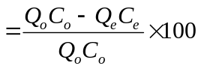 (1)

The second approach estimated the areal removal rate (mg-N m⁻² d⁻¹) as follows:
Removal rate 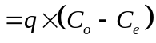 (2)

The third approach estimated the area-based first-order removal rate constants for ammonia (K_{A}) and nitrate (K_{N}) using the K–C* model, assuming plug flow conditions:
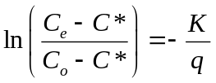 (3)
where Q_{o} and Q_{e} are the daily volumetric water inflow and outflow rates (m³ d⁻¹), C_{o} and C_{e} are influent and effluent concentrations, respectively, of NH₃-N or NO₃-N (mg N L⁻¹), C* is the background concentration (mg N L⁻¹) and K is the areal first-order removal rate constant (m yr⁻¹). The K values were normalised to 20 ºC (K₂₀) based on Eq. (4) using values estimated from Eq. (5). ^{[13]} A C* of 0 mg L⁻¹, recommended by Kadlec ^{[39]} was used to calibrate the model.

The effect of temperature on the areal first-order removal rate constants for the N species was modelled using the modified Arrhenius relationship:
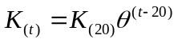 (4)
where K_{(t)} and K₍₂₀₎ are the first-order removal rate constants (m yr⁻¹), t is temperature (ºC), and θ is an empirical temperature coefficient ^{[13]}. A linear form of Eq. (4) was used to estimate parameters of the model from the data set:
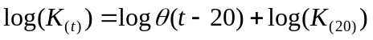 (5)
Values of log(K_{(t)}) versus (t-20) were plotted and fit with a linear regression. The resulting slope and intercept were equal to logθ and log(K₍₂₀₎) respectively.

The hydraulic loading rate, q (m yr⁻¹) was calculated as:
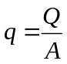 (6)
where Q is the total water inflow rate (m³ d⁻¹), and A is the total surface area for five wetland cells (m²).

The overall dynamic wetland water budget was calculated with Eq. (7).
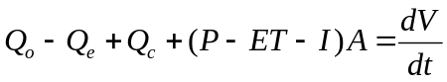 (7)
where Q_{c} is catchment runoff rate (m³ d⁻¹), P is the daily precipitation rate (m d⁻¹), ET is the daily evapotranspiration rate (m d⁻¹), I is the daily infiltration rate (m d⁻¹), and 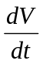is the net change in volume (m³ d⁻¹).

Statistical Analysis

Data distributions were tested for normality. Data presentation uses means of actual measured values. Statistically significant differences were determined at α = 0.01, unless otherwise stated. Comparisons of means were by paired student t-tests and analysis of variance (ANOVA). Regression analysis used the standard least squares fit. All statistical analyses were performed using Minitab 16 statistical software (Minitab Inc., UK).

RESULTS AND DISCUSSION

Wetland Hydrology

Overall, surface flows from the sludge cell and precipitation were considered as the inflow sources to the ICW system, whereas evapotranspiration and water infiltration were assumed to be lost water. Precipitation and evapotranspiration were calculated as the amount of water falling on, or evaporating from the wetland cell surface, respectively. The HLR, HRT, and mean dimensions of each ICW cell are presented in Table 1.

During the study period, highest monthly rainfall (296 mm month⁻¹) was recorded in November 2009 and the lowest (5.6 mm month⁻¹) was recorded in June 2009 (Fig. 2). There was no significant seasonal variation in daily rainfall; however, maximum daily rainfall between months was largely variable.

Domestic wastewater inflow to the ICW varied monthly (Fig. 2), with individual system values ranging between 1.4 - 613 m³ d⁻¹. The average inflow rate (± SD) was 104 ± 106.1 m³ d⁻¹, yielding average hydraulic loading of 7 ± 10.5 mm d⁻¹, whereas the associated discharge at the effluent point ranged from 0 - 492 m³ d⁻¹ with an average (± SD) of 131 ± 179.4 m³ d⁻¹. The average daily outflow volumes recorded for the ICW were higher than the average daily inflow volumes, probably due to precipitation inputs.

The net change in volume recorded during the study period (average ± SD) was 62 ± 371.3 m³ d⁻¹. Overall, precipitation represented approximately 56 % of the total input to the ICW, and suggested that water inflow originated mainly from precipitation. Moreover, a strong linear correlation (R² = 0.97, P < 0.01, n = 708) was observed between precipitation and wetland volumetric flow rate, and suggested that precipitation possibly had a significant influence on the hydraulic loading rate. Evapotranspiration and infiltration constituted about 25 % and 5 % respectively, of water outflows from the ICW system, whereas the effluent accounted for nearly 50 %. Catchment runoff and groundwater inflow were assumed to be negligible. The highest evapotranspiration rate (134 ± 18.4 m³ d⁻¹) was recorded in summer and the lowest (13.7 ± 4.4 m³ d⁻¹) in winter.

Influent and Effluent Nitrogen Concentrations

Overall, NH₃-N was recorded as the dominant species of N contained in the influent wastewater received by the ICW. Annual influent concentrations (average ± SD) of 40 ± 13.6 mg L⁻¹ and 5 ± 3.8 mg L⁻¹ were recorded respectively for NH₃-N and NO₃-N, indicating a high variability of the influent domestic wastewater (Table 3). The NH₃-N concentrations received by the ICW over the study period were slightly higher than other FWS CWs receiving primary domestic effluent, reported by Kadlec and Wallace ^{[14]} and Boutilier et al., ^{[40]} where concentrations varied depending on climate. Other studies such as Ran et al., ^{[41]} have reported slightly higher influent concentrations as well. Average concentrations of N in the ICW effluent were consistently less than 1.0 mg L⁻¹ and recorded an average of 0.8 ± 1.6 mg L⁻¹ for NH₃-N and 0.3 ± 0.2 mg L⁻¹ for NO₃-N. The effluent concentrations of both N species were significantly lower (P < 0.01, n = 120) than the influent.

Furthermore, influent concentrations of the two N species showed some seasonal variations (Table 4). Nevertheless, whereas the variations in concentrations of the influent NO₃-N was significant (P < 0.01, n = 18), variations of the influent NH₃-N was not. The highest (average ± SD) seasonal influent concentration of NH₃-N (42 ± 10.1 mg L⁻¹) and NO₃-N (8 ± 6.3 mg L⁻¹) were recorded in summer and spring respectively (Table 4), and indeed the highest removal rate occurred in the same season. The effluent NH₃-N concentrations were slightly higher in winter (3 ± 3.1 mg L⁻¹) compared to the other seasons. No seasonal variations in the effluent NO₃-N was observed, and was typically in the region of 0.3 mg L⁻¹. The effluent NH₃-N concentrations were highest during winter probably because of increased surface outflow rates ^{[13, 27]} caused by increases in precipitation driven hydrological inputs, which subsequently decreased HRT. Other possible explanations for this increase may include vegetation senescence and subsequent nutrient release from vegetation to the overlying wetland water column during this period. ^{[42]} Additionally, ice cover during the relatively severe winter in late December 2009 through early January 2010, may have created anaerobic conditions and decreased biodegradation, ^{[40]} and may also partly account for the increased effluent NH₃-N concentrations.

Nitrogen Loading and Removal Rates

Generally, the average (± SD) areal NH₃-N loading rate (245 ± 321.9 mg m⁻² d⁻¹) was higher compared to that of NO₃-N (38 ± 58.3 mg m⁻² d⁻¹). Nevertheless, the areal removal rates for the two N species were consistently high, with average (± SD) of 240 ± 317.8 mg m⁻² d⁻¹ for NH₃-N and 35 ± 54.9 mg m⁻² d⁻¹ for NO₃-N. There was a significant linear relationship between the areal loading and removal rates for NH₃-N (R² = 0.99, P < 0.01, n = 120) and NO₃-N (R² = 0.99, P < 0.01, n = 101) (Fig. 3), indicating a near complete areal removal rate. The close fit of the points to the regression line also indicate a remarkably constant areal removal rate for both N species. In general, average annual mass removal efficiencies were relatively high for the ICW. Approximately 92.7 % removal was recorded for NH₃-N and 84.4 % for NO₃-N. Over the two-year study period, surface inflows carried a total load of 2802 kg NH₃-N into the ICW system and 98.0 % were retained. Similarly, a total load of 441 kg NO₃-N had been received by the ICW and 96.9 % retention had been recorded. Hence, nitrogen was effectively removed from the influent wastewater throughout the study period, except during winter (Table 5 and 6), where slightly lower N removal was recorded. The increased HLR owing to excessive rainfall recorded during this season, might have reduced the HRT in the ICW and contributed to the reduced N removal performance during that period. This phenomenon has been observed in previous studies, which have indicated that pollutants removal efficiencies in CWs decreased significantly with HLR. ^{[43-47]} Usually, the HRT is relative high at lower HLR. However, at higher HLR, the wastewater passes rapidly through the wetland, reducing the time available for degradation processes to occur effectively. Also, the ICW surface was frozen from late December 2009 through early January 2010 which may have created anaerobic conditions and decreased biodegradation. ^{[40]}

Area-based first-order N removal rate constants (K) calculated for NH₃-N and NO₃-N reduction in the ICW were 14 ± 16.5 m yr⁻¹ and 11 ± 12.5 m yr⁻¹, respectively (Table 7). Average water temperatures ranged between 4–22 ºC. The average effects of temperature (θ) on N removal rate constants were estimated to be 1.005 for NH₃-N and 0.984 for NO₃-N. This yielded normalised N removal rate constants at 20 ºC (K₂₀) of 15 ± 17.3 m yr⁻¹ and 10 ± 11.3 m yr⁻¹, respectively. The N removal rate constants estimated for the ICW were similar to typical values reported for FWS CWs. ^{[13, 14]} When normalised to 20 ºC, the K₂₀ for N removal increased somewhat for NH₃-N and decreased slightly for NO₃-N, indicating that temperature only marginally influenced N removal. Moreover, the estimated θ for the ICW were found to be slightly lower than θ for reduction of NH₃-N reported by Kadlec and Reddy ^{[48]} and similar to values reported by Kadlec and Wallace, ^{[14]} whereas θ for NO₃-N reduction were generally lower than values reported by Kadlec and Wallace ^{[14]} and Kadlec and Reddy. ^{[48]} The lower θ values indicated that the N removal rate constants were independent of temperature and suggested that little of the variability in N removal by the ICW may be attributed to temperature. Also, there was no correlation observed between water temperature and the kinetic rate constants for both NH₃-N and NO₃-N (Fig. 4). Nevertheless, relatively high N removal rates have been recorded at all times of the year, where the water temperature within the studied ICW ranged only between 4 ºC and 22 ºC, further confirming the low influence of temperature on N removal in the ICW. This is in contrast to earlier reports that N removal in CWs is influenced by temperature. ^{[48]} Previous studies have shown that the biological N removal processes which are responsible for nitrification and denitrification in CWs and accounts for the major N removal pathway, is most efficient at temperature ranges between 25 ºC and 30 ºC. ^{[49-51]} The temperature range recorded in the ICW barely reached this optimum range. Nevertheless, N removal by the ICW was influenced by seasonality, with slightly higher removal recorded during the warmer months. It is possible that this seasonality may have been influenced by plant nutrient uptake. According to Kadlec ^{[41]} plants take up nutrients in the spring and then release them back to the water column during autumn senescence and these seasonal effects may mask the influence of temperature. Also, DO levels within the ICW were generally low. The low DO would contribute to slow biological degradation. This suggests that N removal by the ICW may be largely due to physical processes. Physical treatment processes are less influenced by temperature. A significant linear relationship was observed between the kinetic rate constants and the loading rates for both NH₃-N and NO₃-N (Fig. 5), indicating that physical processes indeed may have played a significant role in the N removal performance of the ICW.

CONCLUSIONS

Following a detailed evaluation of a two-year (April 2008–May 2010) data set comprising influent and effluent loadings of two nitrogen (N) species, namely, ammonia-nitrogen (NH₃-N) and nitrate-nitrogen (NO₃-N), together with total water budgets, ICW can be effective at removing N pollution from domestic wastewater, with comparatively high areal removal rates at all times of the year. Annual mass removal efficiencies were consistently high for the two N species with average of 92.7 % removal for NH₃-N and 84.4 % for NO₃-N. Overall, during the two-year operation, the ICW received a total load of 2802 kg NH₃-N and 441 kg NO₃-N and recorded 98.0 % and 96.9 % removal respectively. Average areal removal rates for NH₃-N and NO₃-N were 240 ± 317.8 mg m⁻² d⁻¹ and 35 ± 54.9 mg m⁻² d⁻¹, respectively and showed significant linear correlations with areal loading rates. Nitrogen removal exhibited some seasonal trends. Removal rates in the summer months were slightly higher. Lowest rates were observed in winter. Areal first-order N removal rate constants in the ICW averaged 14 m yr⁻¹ for NH₃-N and 11 m yr⁻¹ for NO₃-N. The normalised areal removal rate constants suggested that N removal in the ICW were marginally affected by temperature. The temperature coefficients (θ), estimated using the modified Arrhenius equation, were low and further validated the low influence of temperature on N removal in the ICW.

ACKNOWLEDGEMENTS

The authors thank Monaghan County Council for funding this research. Technical support and advice by Ms. Susan Cook (Waterford County Council, Ireland), Mr. Dan Doody, Mr. Mark Johnston and Mr. Eugene Farmer (Monaghan County Council, Ireland) are highly appreciated.

REFERENCES

[1] Black and Veatch Corporation. White's Handbook of Chlorination and Alternative Disinfectants (5th. Ed.). John Wiley and Sons, Inc., New Jersey. 2010.
[2] Ault, T., Velzeboer, R., Zammit, R. Influence of Nutrient availability on Phytoplankton Growth and Community Structure in the Port Adelaide River, Australia: bioassay assessment of potential nutrient limitation. Hydrobiologia 2000, 429, 89-103.
[3] Beutel, M. W. Inhibition of Ammonia Release from Anoxic Profundal Sediments in Lakes using Hypolimnetic Oxygenation. Ecological Engineering 2006, 28(3), 271-279.
[4] USEPA. Drinking Water from Household Wells. EPA 816-K-02-003. United States Environmental Protection Agency, Washington, DC. 2002.
[5] Machate, T., Noll, B. H. H., Kettrup, A. Degradation of Phenanthrene and Hydraulic Characteristics in a Constructed Wetland. Water Research 1997, 31(3), 554-560.
[6] Moshiri, G. A. Constructed Wetlands for Water Quality Improvement. CRC Press, Boca Raton, Florida, USA. 1993.
[7] Kadlec, R. H., Knight, L. R., Vymazal, J., Brix, H., Cooper, P., Haberl, R. Constructed Wetlands for Pollution Control: Processes, Performance, Design and Operation. International Water Association (IWA) Specialist Group on Use of Macrophytes in Water Pollution Control. Scientific and Technical Report No. 8. IWA Publishing, London. 2000
[8] Scholz, M., Xu, J. Performance Comparison of Experimental Constructed Wetlands with Different Filter Media and Macrophytes Treating Industrial Wastewater Contaminated with Lead and Copper. Bioresource Technology 2002, 83(2): 71-79.
[9] Scholz, M. Treatment of Gully Pot Effluent Containing Nickel and Copper with Constructed Wetlands in a Cold Climate. Journal of Chemical Technology and Biotechnology 2004, 79(2): 153-162.
[10] Zhao, Y. Q., Sun, G., Allen, S. J. Anti-sized Reed Bed System for Animal Wastewater Treatment: A Comparative Study. Water Research 2004, 38(12): 2907-2917.
[11] Scholz, M., Lee, B. H. Constructed Wetlands: A Review. International Journal of Environmental Studies 2005, 62(4): 421-447.
[12] US EPA. Handbook of Constructed Wetlands: A Guide to Creating Wetlands for Agricultural Wastewater, Domestic Wastewater, Coal Mine Drainage, and Stormwater in the Mid-Atlantic Region. Volume 2: Domestic Wastewater. Environment Protection Agency, Washington, DC. 1995.
[13] Kadlec, R. H., Knight, R. L. Treatment Wetlands. CRC Press, Boca Raton, FL. 1996.
[14] Kadlec, R. H., Wallace, S. D. Treatment Wetlands (2nd. ed.). CRC Press, Boca Raton, FL. 2009.
[15] Watson, T. J., Reed, S. C., Kadlec, R. H., Knight, R. L., Whitehouse, A. E. Performance Expectations and Loading Rates for Constructed Wetlands. In: Hammer, D. A. (Ed.). Constructed Wetlands for Wastewater Treatment: Municipal, Industrial and Agricultural. Lewis Publishers, Inc., Chelsea, Michigan. 1989, 319-351.
[16] Verhoeven, J. T. A., Meuleman, A. F. M. Wetlands for Wastewater Treatment: Opportunities and Limitations. Ecological Engineering 1999, 12, 5-12.
[17] Luederitz, V., Eckert, E., Lange-Weber, M., Lange, A., Gersberg, R. M. Nutrient Removal Efficiency and Resource Economics of Vertical Flow and Horizontal Flow Constructed Wetlands. Ecological Engineering 2001, 18, 157-171.
[18] Babatunde, A. O., Zhao, Y. Q., O'Neill, M., O'Sullivan B. Constructed Wetlands for Environmental Pollution Control: A Review of Developments, Research and Practice in Ireland. Environment International 2008, 34, 116-126.
[19] Harrington, R., Carroll, P., Carty, A., Keohane, J., Ryder, C. Integrated Constructed Wetlands: Concept, Design, Site Evaluation and Performance. International Journal of Water 2007, 3(3), 243–256.
[20] Scholz, M., Harrington, R., Carroll, P., Mustafa, A. The Integrated Constructed Wetlands (ICW) Concept. Wetlands 2007, 27(2): 337-354.
[21] Harrington, R., Ryder. C. The Use of Integrated Constructed Wetlands in the Management of Farmyard Runoff and Waste Water. In Proceedings of the National Hydrology Seminar on Water Resource Management: Sustainable Supply and Demand. Tullamore, Offaly. 19th Nov. 2002. The Irish National Committees of the IHP and ICID, Ireland. 2002, 55-63.
[22] Nygaard, B., Ejrnæs, R. The Impact of Hydrology and Nutrients on Species Composition and Richness: Evidence from a Microcosm Experiment. Wetlands 2009, 29(1):187-195.
[23] Jurdo, G. B., Johnson, J., Feeley, H., Harrington, R., Kelly-Quinn, M. The Potential of Integrated Constructed Wetlands (ICWs) to Enhance Macroinvertebrate Diversity in Agricultural Landscapes. Wetlands 2010, 30(3): 393-404.
[24] Carty, A., Scholz, M., Heal, K., Gouriveau, F., Mustafa, A. The Universal Design, Operation and Maintenance Guidelines for Farm Constructed Wetlands (FCW) in Temperate Climates. Bioresource Technology. 2008, 99, 6780-6792.
[25] Mustafa, A., Scholz, M., Harrington, R., Carroll, P. Long-term Performance of a Representative Integrated Constructed Wetland Treating Farmyard Runoff. Ecological Engineering 2009, 35(5), 779-790.
[26] Harrington, R., Dunne, E., Carroll, P., Keohane, J., Ryder, C. The Anne Valley
Project: The use of Integrated Constructed Wetlands (ICWs) in Farmyard and Rural Domestic Wastewater management. In: Lewis, D., Gairns, L. P. (Eds). Agriculture and the Environment, Water Framework Directive and Agriculture. Proceedings of the SAC and SEPA Biennial Conference, Edinburgh, 24-25 March 2004. 2004, 51-58.
[27] Dunne, E. J., Culleton, N., O’Donovan, G., Harrington, R., Olsen, A. E. An Integrated Constructed Wetland to Treat Contaminants and Nutrients from Dairy Farmyard Dirty Water. Ecological Engineering 2005, 24(3), 221-234.
[28] Harrington, R., McInnes, R. Integrated Constructed Wetlands (ICW) for Livestock Wastewater Management. Bioresource Technology 2009, 100, 5498-5505.
[29] Vymazal, J. Types of Constructed Wetlands for Wastewater Treatment: Their Potential for Nutrient Removal. In: Vymazal, J. (Ed.) Transformations of Nutrients in Natural and Constructed Wetlands. Backhuys Publishers, Leiden, The Netherlands. 2001, 1-93.
[30] Scholz, M. Wetland Systems to Control Urban Runoff. Elsevier, Amsterdam, The Netherlands. 2006.
[31] Vymazal, J. Removal of Nutrients in Various Types of Constructed Wetlands. Science of the Total Environment, 2007, 380, 48-65.
[32] Spieles, D. J., Mitsch, W. J. The Effects of Season and Hydrologic and Chemical Loading on Nitrate Retention in Constructed Wetlands: A Comparison of Low- and High Nutrient Riverine Systems. Ecological Engineering 2000, 14, 77-91.
[33] Crumpton, W. G., Phipps, R. Fate of Nitrogen Loads in Experimental Wetlands. In: The Des Plaines River Wetlands Demonstration Project. Wetlands Research, Inc., Chicago, IL. 1992.
[34] Kuschk, P., Wiebner, A., Kappelmeyer, U., Weibbrodt, E., Kastner, M., Stottmeister U. Annual Cycle of Nitrogen Removal by a Pilot-Scale Subsurface Horizontal Flow in a Constructed Wetland under Moderate Climate. Water Research 2003, 37, 4236-4242.
[35] Lee, C., Fletcher, T. D., Sun, G. Nitrogen Removal in Constructed Wetland Systems. Engineering Life Science 2009, 9(1), 11-22.
[36] Sakadevan, K., Bavor, H. J. Nutrient Removal Mechanisms in Constructed Wetlands and Sustainable Water Management. Water Science and Technology 1999, 40, 121-128.
[37] Met Éireann. Climate of Ireland. Online: http://www.met.ie/climate/climate-of-ireland.asp [12/05/10]. 2010.
[38] HACH Company. Procedures Manual. Spectrophotometer DR 2010 49300-22. (7th ed.). Loveland, CO. 2000.
[39] Kadlec, R. H. Comparison of Free Water and Horizontal Subsurface Treatment Wetlands. Ecological Engineering, 2009, 35, 159-174.
[40] Boutilier, L., Jamieson, R., Gordon, R., Lake, C., Hart, W. Performance of Surface-flow Domestic Wastewater Treatment Wetlands. Wetlands 2010, 30, 795-804.
[41] Ran, N., Agami, M., Oron, G. A Pilot Study of Constructed Wetlands using Duckweed (Lemna gibba L.) for Treatment of Domestic Primary Effluent in Israel. Water Research
2004, 38(9), 2241-2248.
[42] Kadlec, R. H. Pond and Wetland Treatment. Water Science and Technology 2003, 48(5), 1-8.
[43] Tanner, C. C, Clayton, J. S., Upsdell, M. P. Effect of Loading Rate and Planting on Treatment of Dairy Farm Wastewaters in Constructed Wetland–I. Removal of Oxygen Demand, Suspended Solids and Faecal Coliforms. Water Research 1995, 29(1), 17-26.
[44] Tanner, C. C., Clayton, J. S., Upsdell, M. P. Effect of Loading Rate and Planting on Treatment of Dairy Farm Wastewaters in Constructed Wetland–II. Removal of Nitrogen and Phosphorus. Water Research 1995, 29(1), 27-34.
[45] Huang, J., Reneau Jr., R. B., Hagedorn, C. Nitrogen Removal in Constructed Wetlands Employed to Treat Domestic Wastewater. Water Research 2000, 34(9), 2582-2588.
[46] Chung, A. K. C., Wu, Y., Tam, N. F. Y., Wong, M. H. Nitrogen and Phosphate Mass Balance in a Sub-Surface Flow Constructed Wetland for Treating Municipal Wastewater. Ecological Engineering 2008, 32(1), 81-89.
[47] Trang, N. T. D., Konnerup, D., Schierup, H. H., Chiem, N. H., Tuan, L. A., Brix, H. Kinetics of Pollutant Removal from Domestic Wastewater in a Tropical Horizontal Subsurface Flow Constructed Wetland System: Effects of Hydraulic Loading Rate. Ecological Engineering 2010, 36(4), 527-535.
[48] Kadlec, R. H., Reddy, K. R. Temperature Effects in Treatment Wetlands. Water Environment Research 2001, 73(5), 543-557.
[49] Hammer, D. A., Knight, R. L. Designing Constructed Wetlands for Nitrogen Removal. Water Science and Technology 1994, 29(4), 15-27.
[50] Vymazal, J. Nitrogen Removal in Constructed Wetlands with Horizontal Sub-surface Flow–Can We Determine The Key Process? In: Vymazal, J. (ed.). Nutrient Cycling and Retention in Natural and Constructed Wetlands. Backhuys Publishers, Leiden. 1999, 1-17.
[51] Mitsch, W. J., Horne, A. J., Narin, W. R. Nitrogen and Phosphorus Retention in Wetlands–Ecological Approaches to Solving Excess Nutrient Problems. Ecological Engineering 2000, 14, 1-7.

LIST OF FIGURE CAPTIONS

Figure 1. Schemata of ICW cells located at Glaslough in Co. Monaghan, Ireland showing all sampling locations
Figure 2. Average rainfall and water fluxes at influent and effluent points of ICW between 2008 and 2010
Figure 3. Areal loading and removal rates for (a) Ammonia, (b) Nitrate in ICW between 2008 and 2010
Figure 4. Water temperature and reaction rate constants for (a) Ammonia, (b) Nitrate in ICW between 2008 and 2010
Figure 5. Nitrogen loading rate and reaction rate constants for (a) Ammonia, (b) Nitrate in ICW between 2008 and 2010

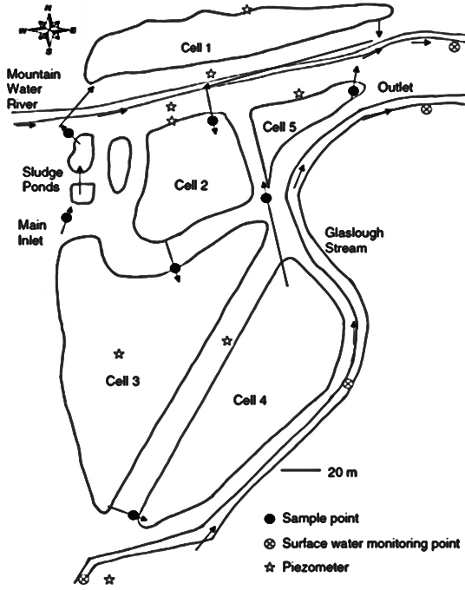

Fig.1

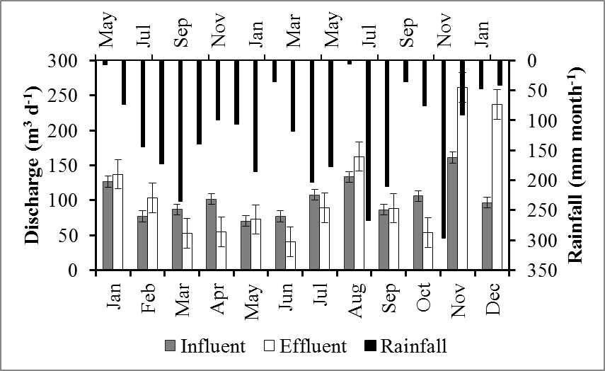

Fig.2

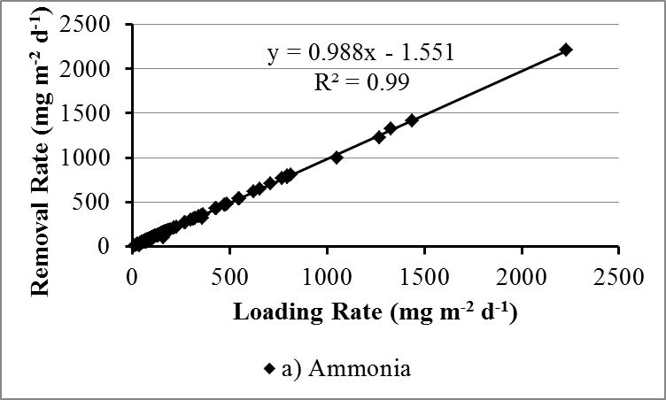

Fig.3a

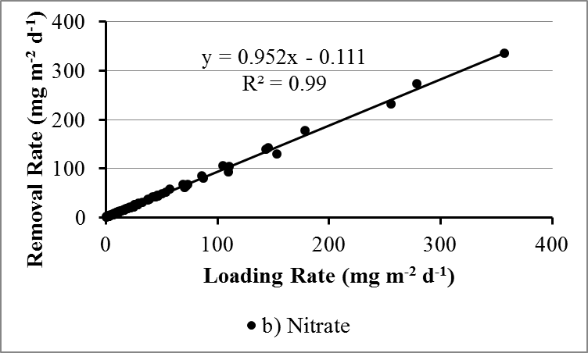

Fig.3b

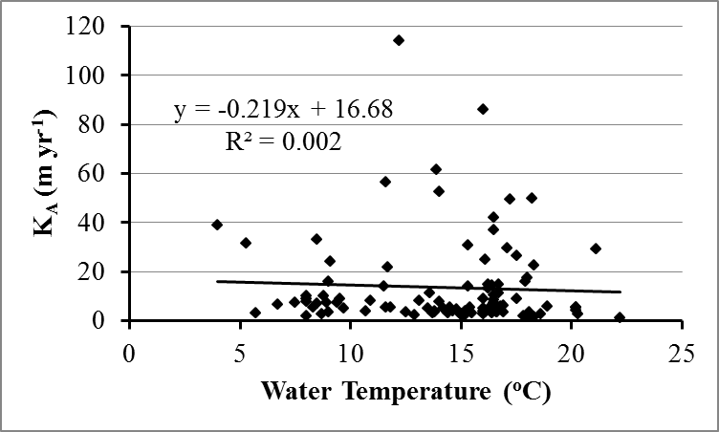

Fig.4a
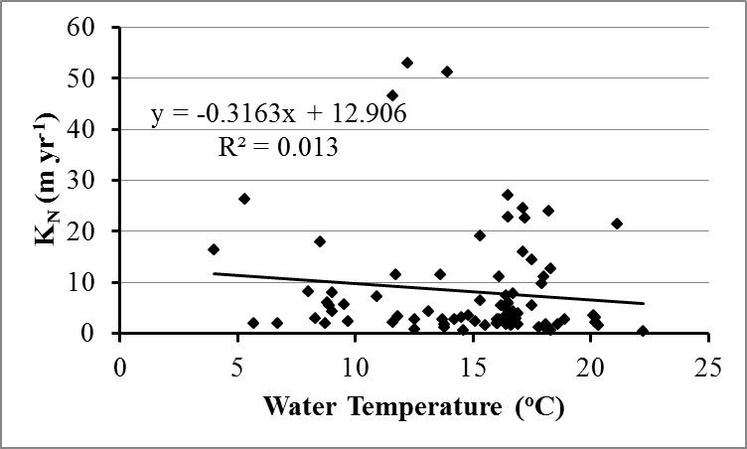

Fig.4b

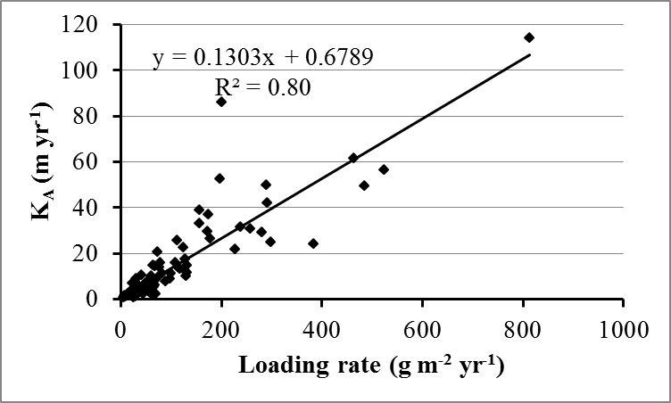

Fig.5a

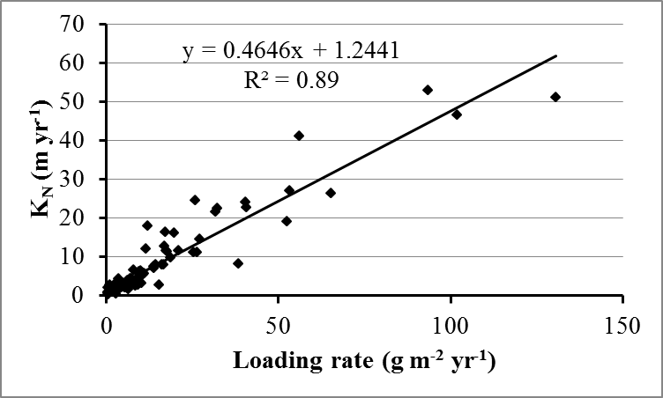

Fig.5b
Table 1: Dimensions and hydraulic characteristics of ICW system
ICW section | Area (m²) | Depth (m) | Volume (m³) | HRT (d) | HLR (mm day⁻¹)
Pond 1 | 4664 | 0.42 | 1958.9 | 18 | 24.4
Pond 2 | 4500 | 0.38 | 1710.0 | 16 | 26.8
Pond 3 | 12660 | 0.32 | 4051.2 | 32 | 10.7
Pond 4 | 9170 | 0.36 | 3301.2 | 23 | 16.1
Pond 5 | 1460 | 0.29 | 423.4 | 3 | 100.3
Total wetland | 32454 | - | 11444.7 | 92 | 7.3

Table 2. Daily water fluxes and distribution of total water budget for ICW between April 2008 and May 2010
Water fluxes  (m³ d⁻¹) | Cell 1 |  | Cell 2 |  | Cell 3 |  | Cell 4 |  | Cell 5 |  | Total ICW
Water fluxes  (m³ d⁻¹) | Mean | SD | Mean | SD | Mean | SD | Mean | SD | Mean | SD | Mean | SD
Inputs:
Wastewater inflow | 104 | 106.1 | 112 | 132.4 | 109 | 134.3 | 128 | 158.5 | 143 | 191.6 | 104 | 106.1
Precipitation | 21 | 46.1 | 20 | 44.5 | 57 | 125.1 | 41 | 90.6 | 7 | 14.4 | 139 | 65.7
Outputs:
Wetland effluent | 112 | 132.4 | 109 | 134.3 | 128 | 158.5 | 143 | 191.6 | 131 | 179.4 | 131 | 179.4
Evapotranspiration | 4 | 3.5 | 4 | 3.4 | 16 | 12.9 | 8 | 6.9 | 1 | 1.1 | 39 | 27.9
Infiltration | 1.6 |  | 1.5 |  | 4.4 |  | 3.2 |  | 0.5 |  | 11.2

Table 3. Influent and effluent nitrogen concentrations at ICW between April 2008 and May 2010
Parameter | Unit | Influent |  | n | Effluent |  | n
Parameter | Unit | Mean | SD | n | Mean | SD | n
Ammonia | mg N L⁻¹ | 40 | 13.6 | 120 | 0.8 | 1.6 | 120
Nitrate | mg N L⁻¹ | 5 | 3.8 | 101 | 0.3 | 0.2 | 101
n = sample number, SD = standard deviation

Table 4. Comparison of seasonal nitrogen concentrations at ICW influent and effluent points between 2008 and 2010
Season | Months | NH₃-N (mg L⁻¹) |  |  |  |  | NO₃-N (mg L⁻¹)
Season | Months | n | Influent |  | Effluent |  | n | Influent |  | Effluent
Season | Months | n | Mean | SD | Mean | SD | n | Mean | SD | Mean | SD
Spring | 1 Feb - 30 Apr | 22 | 41 | 11.9 | 1 | 1.9 | 13 | 8 | 6.3 | 0.2 | 0.1
Summer | 1 May - 31 Jul | 47 | 42 | 10.1 | 0.3 | 0.2 | 45 | 5 | 2.1 | 0.3 | 0.2
Autumn | 1 Aug - 31 Oct | 34 | 40 | 17.3 | 0.3 | 0.2 | 28 | 4 | 1.5 | 0.4 | 0.2
Winter | 1 Nov - 31 Jan | 17 | 31 | 11.5 | 3 | 3.1 | 15 | 2 | 1.6 | 0.3 | 0.1
n = sample number, SD = standard deviation

Table 5. Comparison of seasonal ammonia loading and removal rates in ICW between 2008 and 2010
Season | Months | n | Total inputs  (mg m⁻² d⁻¹) |  | Total outputs  (mg m⁻² d⁻¹) |  | Removal rate
Season | Months | n | Mean | SD | Mean | SD | (mg m⁻² d⁻¹) | %
Spring | 1 Feb - 30 Apr | 22 | 181 | 242.8 | 3.0 | 6.65 | 187 | 96.3
Summer | 1 May - 31 Jul | 47 | 278 | 347.7 | 0.5 | 0.79 | 275 | 99.5
Autumn | 1 Aug - 31 Oct | 34 | 255 | 395.3 | 1.2 | 2.44 | 253 | 98.4
Winter | 1 Nov - 31 Jan | 17 | 204 | 108.4 | 25.2 | 33.60 | 187 | 57.6
n = sample number, SD = standard deviation

Table 6. Comparison of seasonal nitrate loading and removal rates in ICW between 2008 and 2010
Season | Months | n | Total inputs  (mg m⁻² d⁻¹) |  | Total outputs  (mg m⁻² d⁻¹) |  | Removal rate
Season | Months | n | Mean | SD | Mean | SD | (mg m⁻² d⁻¹) | %
Spring | 1 Feb - 30 Apr | 13 | 44 | 48.8 | 0.6 | 0.62 | 43 | 94.5
Summer | 1 May - 31 Jul | 45 | 44 | 70.3 | 0.5 | 0.55 | 41 | 96.2
Autumn | 1 Aug - 31 Oct | 28 | 35 | 54.9 | 1.7 | 3.39 | 32 | 88.6
Winter | 1 Nov - 31 Jan | 15 | 19 | 16.1 | 2.5 | 2.24 | 16 | 60.8
n = sample number, SD = standard deviation

Table 7. Area-based first-order removal rate constants for ammonia and nitrate
Parameter | K (m yr⁻¹) |  |  | K₂₀ (m yr⁻¹) |  |  | θ
Parameter | Mean | SD | n | Mean | SD | n | θ
Ammonia | 14 | 16.5 | 120 | 15 | 17.3 | 101 | 1.005
Nitrate | 11 | 12.5 | 101 | 10 | 11.3 | 101 | 0.984
n = sample number, SD = standard deviation,
K = area-based rate constant, K₂₀ = normalised rate constant

